**[Java Programming Lab (CSE 207L)](https://classroom.google.com/u/0/c/NDY2NDA0MDgyMjk5" \t "_self)**

**Dept. of Computer Science and Engineering**

**IV Semester**

**JAVA**

# **Exercise on file programming**

****

**R. Chandu Badrinath Manikanta**

**(AP20110010188)**

1)

class Main

{

public static int count(String s, char c)

{

int res = 0;

for (int i=0; i<s.length(); i++)

{

// checking character in string

if (s.charAt(i) == c)

res++;

}

return res;

} //This Program is written by R.Chandu BNM

// Driver method

public static void main(String args[])

{

String str= "SRM University, Andhra Pradesh, also known as SRM University, Amaravati, is a private university located near Neerukonda village in Mangalagiri mandal of Guntur district in Andhra Pradesh, India, in the area of the planned capital city Amaravati.";

char c = 'e';

System.out.println(count(str, c));

}

}

**OUTPUT SCREEN**

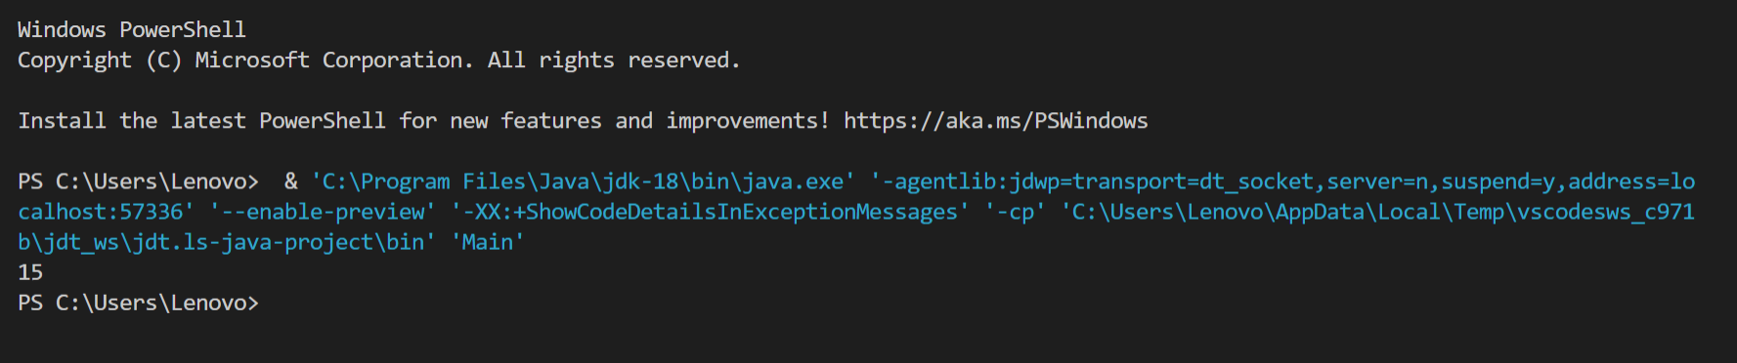

2)

import java.io.\*;

public class ReadFile

{

public static void main(String[] args) throws Exception

{

FileReader fr=new FileReader("D:\\srm.txt");

int i;

while((i=fr.read())!=-1)

System.out.print((char) i);

}

}

**OUTPUT SCREEN**

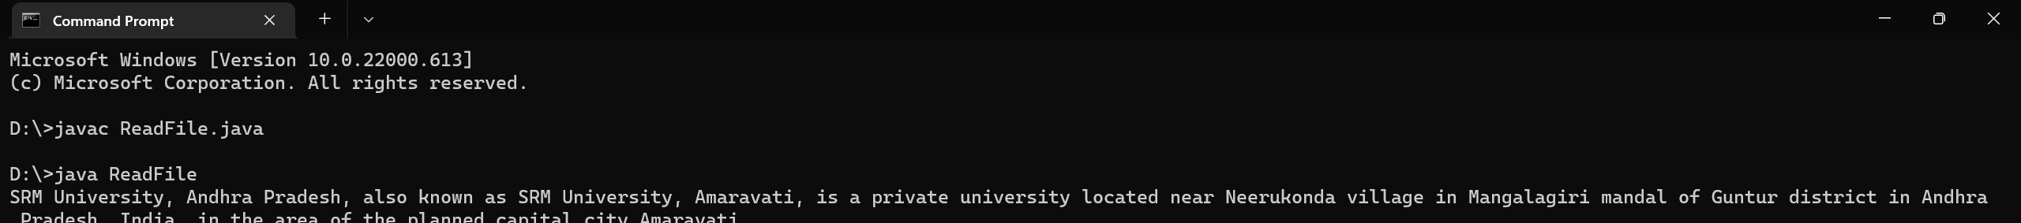

3)

import java.io.\*;

class WriteFile

{

public static void main(String[] args)

{

String str= "Embark on the avenues of excellence with SRM University-AP! Believing in the power of education to transform lives, our interdisciplinary research-oriented undergraduate, postgraduate, and doctoral programmes ensure global exposure and entrepreneurial experience to our students. We are a thriving intellectual community prepared for a dynamic world.";

try

{

FileWriter fw=new FileWriter("D:\\srm.txt",true);

fw.write(str);

fw.close();

}

catch(IOException e){}

}

}

//This Program is written by R.Chandu BNM

**OUTPUT SCREEN**

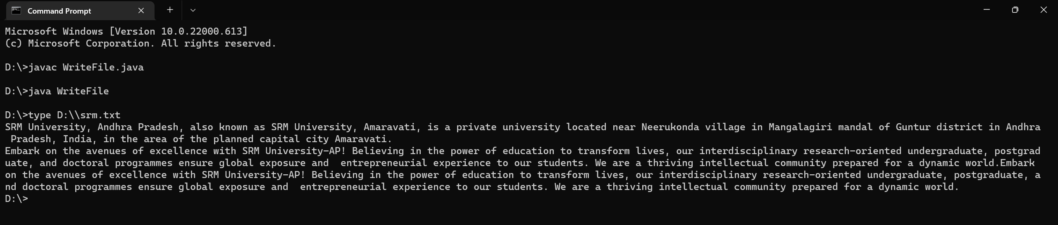

4)

import java.util.Scanner;

import java.io.File;

import java.io.FileNotFoundException;

class Problem4{

public static void main(String [ ] args) throws FileNotFoundException {

new Problem4().findLongestWords();

}

public String findLongestWords() throws FileNotFoundException {

String longest\_word = "";

String current;

Scanner sc = new Scanner(new File("srm.txt"));

//This Program is written by R. Chandu BNM

while (sc.hasNext()) {

current = sc.next();

if (current.length() > longest\_word.length()) {

longest\_word = current;

}

}

System.out.println("\n"+longest\_word+"\n");

return longest\_word;

}

}

**OUTPUT SCREEN**

